Statistical Analysis of EEG Dataset

About the Dataset:

* Number of subjects: 11
* EEGsample shape: (2022, 30, 384)
* Number of Samples: 2022
* Number of Channels: 30
* Number of Time Points: 384
* Sample Duration (seconds): 3.0
* Unique labels: [0 1]
* Label counts: [1011 1011]

The initial exploration of the EEG dataset reveals the following details:

**EEG Samples (EEGsample):**

* The dataset contains 2022 EEG samples.
* Each EEG sample is from 30 channels.
* Each channel has 384 data points, corresponding to a 3-second EEG recording at a sampling rate of 128Hz.

**Subject States (substate):**

* There are two unique states: 0 representing the alert state and 1 representing the drowsy state.
* Each state has 1011 samples, indicating a balanced dataset with respect to the two states.

**Subject Indexes (subindex):**

* There are 11 unique subjects in the dataset (labeled 1 to 11).
* The distribution of samples across subjects varies, ranging from a minimum of 102 samples to a maximum of 314 samples per subject.

Distribution of Subindex and Substate Values

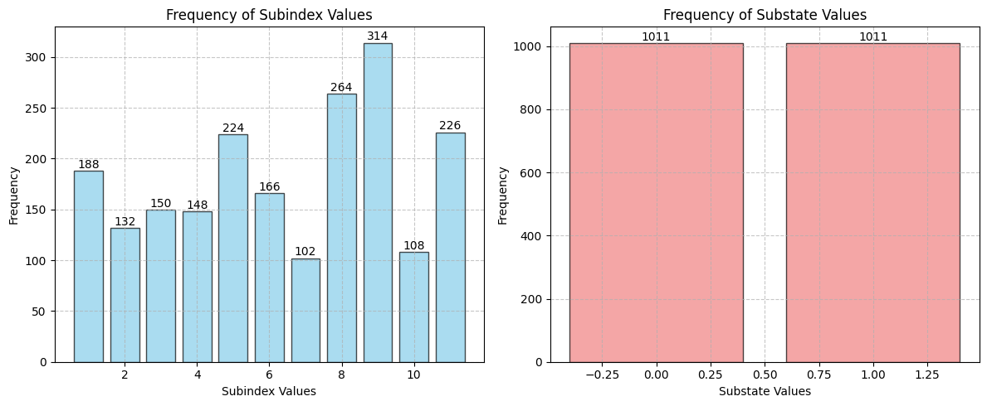

Analysis of Substate Distribution Across Subindices

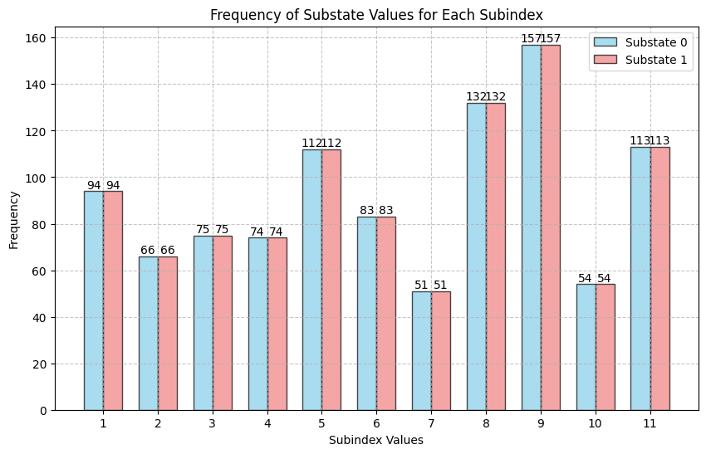

State-specific Analysis: 'Alert' and 'Drowsy'

The following table represents the average (mean) and variability (standard deviation) for each brain channel in the 'Alert' and 'Drowsy' states across all 11 subjects.

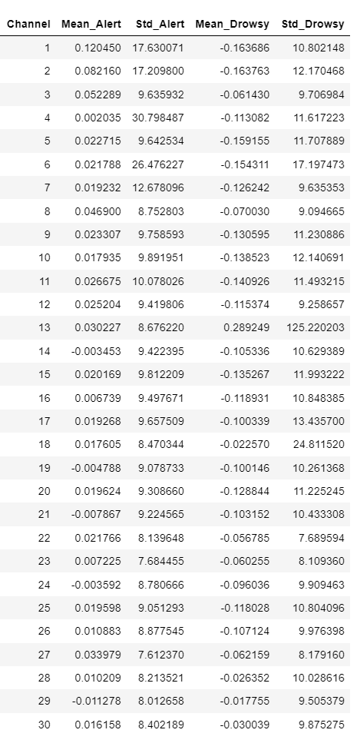

**Table:** State-specific Analysis: 'Alert' and 'Drowsy'

Plotting Details

EEG Waveforms Comparison: Separate Subplots for Each Channel

Each subplot represents a specific channel, displaying the mean EEG signal over time for both Alert and Drowsy states.

Figure Labelled as “**Separate Subplots for Each Channel.png**”

EEG Waveforms Comparison: Combined Plots for All Channels

Each subplot represents a specific channel, displaying the mean EEG signal over time for both Alert and Drowsy states.

Figure Labelled as “**Combined Plots for All Channels.png**”

EEG Data Visualization for Multiple Subjects and Channels

For each subject, a dedicated figure is generated, and within each figure, there are individual subplots for each EEG channel.

Folder Labelled as “**EEG Data Visualization for Multiple Subjects and Channels**”